Introducing Myself: A Journey of Abuse, Grooming Rings, Survival and Empowerment in the Scottish Borders
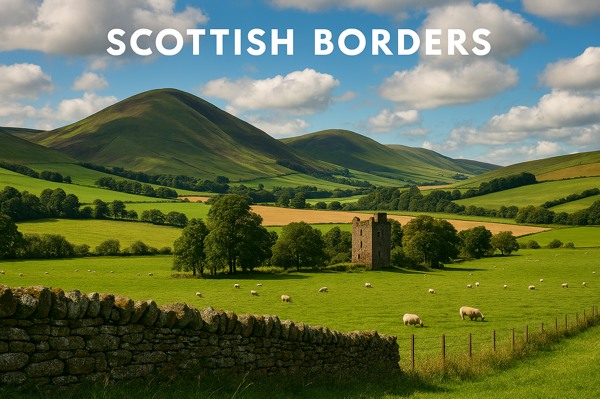
Good afternoon. My name is Seb, and it is a privilege to share my story with you today. I am here not only to introduce myself but to bring to light a journey marked by abuse, hope, and transformation—a journey that began amid the rolling hills and ancient stone villages of the Scottish Borders, a place whose quiet beauty offered both refuge and complexity as I faced the most difficult chapters of my life.
The Scottish Borders, known for its stunning landscapes and tightly woven communities, shaped my early understanding of belonging and trust. From childhood, I believed in the promise of safety and kindness. Yet beneath that tranquil surface, I encountered experiences that would challenge every certainty. As a young person, I was groomed—drawn in by those who used affection and manipulation to isolate and control me. The grooming rings that operated even in rural settings exploited vulnerability, turning trust into a weapon.
Abuse and grooming did not take place in isolated shadows; they unfolded in the very environments we often consider safe and familiar. The grooming rings thrived not just in hidden corners but in everyday places—schools, local neighborhoods, cafes, taxis, shops, bars, colleges, and offices. These spaces, woven into the fabric of daily life in the Scottish Borders, became settings where exploitation could occur under the guise of normalcy. Group-based sexual grooming and exploitation were enabled by networks that operated in plain sight, manipulating trust within communities and taking advantage of the routines that shaped our lives. It was in these places—where laughter, learning, and work should have been protected—that I experienced betrayal and manipulation, often by those who appeared outwardly respectable or friendly.
It is important for me to explain that the abuse and exploitation I experienced were not confined to a single moment or phase of life. They occurred across decades, beginning in early childhood, continuing through childhood years and my youth, extending into and throughout my adulthood. 4 decades. The harm was cumulative, shaped by different forms of manipulation, control and exploitation at different ages. What began as early vulnerability was repeatedly targeted with the patterns of abuse adapting to my age and environment, leaving long term impacts in my adult life.
This all happened hidden in plain sight in a picturesque region of quiet towns and villages, eventually extending to Edinburgh and Northern England. The grooming, abuse, violence and exploitation was and is carried out by everyday people in everyday surroundings, all around us in every community.
Throughout my journey, I have spoken with local and national politicians, as well as journalists and podcasters, sharing my story to raise awareness and advocate for meaningful change. These conversations have helped amplify the voices of survivors and shine a light on the realities too often kept hidden. Now, I am building a project and community dedicated to empowering other survivors—providing a safe and authentic space for them to find their voice, share their truths, and support one another in healing and growth.
At the heart of my journey is also my identity: I am a transgender man, born female with both female lived experience and transgender lived experience. Today, I am happy, at peace, and comfortable and secure in who I am.
As my story unfolded, the abuse escalated. I fell victim to sexual violence, suffering at the hands of individuals who masked cruelty with false care. The manipulation was deliberate and devastating, leaving deep scars on my sense of self. Over time, the exploitation grew, and I became entangled in local trafficking—a world where control, fear, and profit took precedence over humanity. The trauma of these experiences is hard to put into words, but it is vital to speak truthfully, to confront the realities that so many endure in silence.
Surviving such violence and manipulation was not simply about enduring—it was about reclaiming the right to exist, to be seen, and to be valued. For years, I was burdened by shame and guilt, believing that I was somehow responsible for what had happened to me. The web of lies woven by abusers is strong, and it takes immense courage to break free. The turning point came when I sought help from a friend within my Borders community, someone who listened without judgment and believed in my worth. That act of reaching out was the beginning of my liberation.
Recovery is a journey, not a destination. There were days when despair threatened to overwhelm me, and nights when memories haunted every moment. Therapy provided a safe space to unravel the manipulation and rebuild my sense of self. Support groups, both local and online, helped me see that I was not alone—that there were others who had walked similar paths and were forging their own routes to recovery. Each step forward brought new strength, and little by little, I reclaimed my self-worth.
The Scottish Borders community played a profound role in my healing. In a region where neighbours know one another, compassion can flourish. Kind strangers, advocates, and fellow survivors offered encouragement and empathy, reinforcing the belief that no one should ever feel isolated by their suffering. Through sharing my story, listening to others, and fostering connections, I discovered that mutual support can transform pain into purpose and despair into hope.
Today, my mission is to turn my experience into empowerment. I speak out about grooming, sexual violence, trafficking, and the manipulation that so often remains hidden. I strive to raise awareness and to encourage others to seek help, to believe in their own resilience, and to remember that self-worth can always be regained. Survival is not just about escaping the grasp of abuse, it is about reclaiming joy, dignity, and the promise of a future unburdened by fear.
I am sharing my experience not only as a survivor, but as a campaigner, advocate and someone seeking sustainable change. Meaningful and survivor led change. The abuse and exploitation I and others endured for decades reveals serious gaps in safeguarding, protection and prevention within authorities, agencies and the wider society. My aims include helping to identify where systems fail, where warning signs are missed or discarded and how these failures can be addressed. By confronting these gaps honestly, we can work together towards stronger protections, deeper understanding, more accountable systems and more resilient communities. Listen to and involve survivors. We hold insights, wisdom and knowledge. Don’t just talk about us, talk to us.
If you are listening and find yourself struggling, please know that you are not alone. There is help, there is hope, and there is extraordinary courage within you. Reach out, speak your truth, and let others walk beside you. Together, our voices can break cycles of silence, confront injustice, and inspire lasting change.
Thank you for allowing me the opportunity to share my journey from the Scottish Borders. I stand here today, grateful and empowered, turning adversity into advocacy, pain into grace, and hope into action. Let us move forward together—with compassion, understanding, and the unwavering conviction that every person deserves to live free, safe, and valued. Thank you.
Truth matters. Survivors matter. Hop matters. Voices matter

